The Dark Below

(if they remain the same characters) - So it’s been a 15 years since helping Gundren Rockseeker, finding the forge of spells and wave echo cave. In the past 15 years you have each gone your own way doing you own things. **(allow the players to say one thing they have done. Some of the things they can say** **(They have been in the Frozen shores of the north fighting the hordes of the chaos for Money, They have been East across the sea fighting pirates and searching for the lost island of Vancur (An island where the largest collection of magic tomes was kept until it completely vanished) They have been in The Dark Below, the tunnels are around five miles underground, the player has been venturing with a group of Dwarves fighting against the subterranean monsters of the world. They have been South in Temerigaard, the new emperor allowed free travel across the realms once again so they travelled south helping the common folk, fighting bandits, or working with a mercenary company.** **They could have been to the west in the Badlands, this is a harsh land where hordes of orcs fight one another for control over the region, they went and lived with a band of orcs for a few years before returning to Neverwinter.)**

All characters know about the Lost mines of Phandelver as they are a famous event – Also a lot of the charcters are friends with Valter Sin and others in the city.

(whichever characters you choose) - Today you have finished your adventures and your long travels, to return to Neverwinter for one important day. Today is the funeral for the King you once saved, the king has died, his death was of natural causes, after you saved his life the king went on to rule the realm with prosperity and the lands flourished. Phandalin grew after you left, the redcloaks helped keep the peace with all kinds of forces. They repelled a large horde of Hobgoblins and are known as heroes throughout the lands now. Thundertree was rebuilt and once again became a jewel in this land. However today as you stand in the main streets of Neverwinter you only see sadness and grief amongst the people. The kings large column of knight ride past, their armour has been rubbed down with coal so the armour is black. The whole city is in grief a singular bell rings throughout the city.

The head of the knights rides past each of you, you recognise him as Valter Sin “The dragonslayer” he gives each of you a sombre nod as there is no time for catching up he rides past. The kings large ornate glass coffin rides past, it seems the wizards of the city have been busy, they have perfectly preserved the king in his prime. He looks as he did 15 years ago. As the coffin passes people thrown roses onto the ground before it, and you hear a few voices shout out “With the gods”.

You each take your time and walk into the tavern, you haven’t set foot in this place for near 15 years, “the clogged keg”. The inkeep doesn’t recognise you and offers you free food and drink during this time of mourning. You each catch a glimse of your fellow adventuring friends and re-unite after all this time. The inkeep also offers you each a room to stay in for a few nights, until the mourning days are over and life tries to return to normal.

A few days pass and the city begins to return to normal, the knights all around the city still coat their armour in coal to show that they are in Mourning still. This morning as you are eating breakfast a familiar face walks through the doors. Valter Sin, the room grows silent and the first person to talk is the Innkeep. “Hail Dragonslayer, is it Food or Drink you need?” Valter doesn’t reply to the innkeep and his visor remains closed.

He approaches in his coal black armour, and though his voice echoes in his helmet, you can tell he is in an uplifting mood, “My old friends, greetings”.

* The players can ask him a multitude of question, Valter knows most of the answers if they are relating to the open world.
* He tells you that phandalin is the second largest settlement in this region, smaller still than Neverwinter it is large. A very large stone wall surrounds it now, The Redcloaks guard it and the mayor of the city Halia Thornton rules in this time of peace.
* Gundren has his own small business where he sells the valuables he finds in the lost mines of phandelver to various traders, making a lot of money along the way.
* The king died of natural causes in his bed, he had been getting weak for a few months now and died in his sleep.
* The emperor of Temerigaard routed out all the lords of the south that stood against him and stomped them out and replaced these unloyal lords with people loyal to him.
* The emperor has invaded some smaller Southern Countries to grow his large realm. He currently rules over more people than the rest of the world combined. He also has the largest army in the world, the king was worried that he may turn his army to the North.
  + Rumour has it that the emperor is known to enjoy the company of various races, he also enjoys the company of wizards.
* Other than above Valter Sin doesn’t know anything else.

After a short while Valter raises his visor, his eyes are bloodshot and he looks like he hasn’t slept in a few days.

* If asked Valter says that he is standing vigil over the kings body for seven days and seven nights, until then he will not sleep.

Valter brings up this after a while “my friends I am glad you are here, please I must speak to you in private, it is important.”

* Valter leaves the room and makes his way into the back room of the inn.
  + The room is lit very dimly
  + In the middle of the room is one rectangle table and a few chairs
  + Valter asks each of you to sit.

Once all of the players have taken their seats, Valter locks the door to the room “I am sorry for all of this cloak and dagger business, but what I have to tell you is important, I need you to swear to me right now that you will not tell a soul, blood oath.” – The players must all do this for Valter to speak.

* Valter speaks softly to the players
  + “My friends, I have something to tell you, as of two days ago Emperor Emyhir has laid claim to our realm, his army has been marching for 3 full days so far, he will be at the border in a few days and within a week he will be at our gates. I need your help my friends.”
  + According to our spies, the Emperor has been tunnelling into what is known in his language as “Darquen Bask” or in our language “The Dark Below”. With his tunnelling he has made contact with the Drow elves down there.
  + Apparently he is moving a lot of his army through these tunnels so he can attack our lands whilst his main army attacks the cities. What I need you to do is to go into “The Dark Below” find the drow queen and put a stop to the treaty she has made with the emperor which ever way you can. There is no law in those tunnels.

The group must accept this quest otherwise the whole realm will fall into ruin under the emperor (at least this is what Valter and others believe).

The next day the party has gathered their belongings and on horseback they are making their way down to the mere of dead men. You encounter no troubles along the way, however on the second day (the news has spread across the realm) you ride through abandoned villages with no souls in sight, all of them fleeing the war and only taking essentials with them.

Upon reaching the second empty village a traveller on horseback is waiting for you, the man sits tall on his mighty warhorse, his polished armour is gleaming in the sunlight. You can see his Yellow and Bronze scales from where you are and as you approach he rides forward and lifts his arm of liquid silver. “Hail old friends!” You recognise the man as Falchion Dreyar the Dragonborn paladin.

You can ask Falchion any amount of questions, he will try to answer them whilst you ride, you will not be stopping for breaks now however, so you will have to ride on through the night.

* It is almost midnight when you ride in the mere of dead men. The mere is a large area of marshland. The area stinks of rotting leaves and grass and at night an eerie mist has settled around the marshes.
* Valter knows which way to go however even through the mist. He and Falchion light torches and take point through the mist.

After a few minutes in the mist you come across a small group of armed men. They do not seem to be bandits and they don’t seem to be commoners.

* There are 15 people in this group.
* They are all wearing armour
* They all have longswords and shields and they are carrying a flag.
* The flag is a golden sun on a black field – The flag of Temerigaard

Valter Sin is the first to React, followed quickly by Falchion. Roll initiative.

* Valter can get through any armour on the roll of a 10 or above as he is a highly trained knight. He is so used to fighting dragons that when fighting humans valter can fight up to five at a time.
  + Valter rolls a D10 per enemy he is engaging and adds 3 to his damage rolls.

Falchion acts like a standard character according to his character sheet.

The enemy knights are well trained and tough, they have an armour of 16 and +4 to attack rolls, they deal 1d8 + 2 damage with the longsword. They have 21 hit points each.

* The party may or may not defeat these knights.

No matter the outcome the same thing happens.

After the players have killed the knights/Before the players are killed by the knights, arrows come out of the mist. The strike (the knights) the players and lodge in your skin. You slowly begin to feel drowsy and you fall unconscious before you can react.

When you come to, you are in a smallish cage on the wagon. All of the other players are around you, however Valter and Falchion are in another cage to your right. You cannot move or do magic as you are chained tightly and the chains seem to be imbued with some sort of magical properties.

At the front of the wagon you can see three humanoids, one is holding reins and the others are talking. If a character speaks elvish they can understand what is being said.

* “So why are we taking them to Groll and not to the queen?”
* “Groll gives us gold, the queen will just kill them and not reward us with anything”

You are riding for a few days. The drow give you a small amount of food and water, just enough to keep you alive, on the second day you are delivered to a very large army camp.

* With a roll of DC10 (history) the player recognises this location, it is in the Southern continent of Temerigaard. You are about 1 days ride from the border. The large camp belongs to the empire of Temerigaard. The soldiers holler and laugh as you ride past. Some of them even spit and throw rotting food at you.
* Your wagon comes to a stop, however Valter and Falchion are taken further on away from you.
  + As you are dragged forward in your chains a large brutish half orc approaches you.
  + He is over 7 feet tall, his skin is a light green, and he has a small black mohawk, which is common amongst orc gladiators.
  + He has yellow eyes and has various tattoos over his face and arms.
    - On a DC10 intelligence check a player notices that these tattoos are from various cities and realms, some of them being tattoos for winning large tournaments and others being from slaying mighty beasts.
  + He is wearing full plate mail and is wielding a large maul which is adorned with monster teeth.

“So you’re the fresh meat these stinking drow have brought me? HA!” – “ You don’t even look like you’re worth a single copper, they should have taken you to their queen” – “Well we can send you into the mines, the empire always needs more iron.” – “Firstly though, we need to show you just how serious we are about people who try to escape. Take them to the mines, detour to the pits.”

This large half orc makes a small hand gesture and you are shuffled into the wagon, The wagon rolls further down the camp and you come past a hole which is around 10 feet deep. Inside the hole is a large wooden post, chained to that post is Falchion.

* As you are sat in your wagon you are forced to watch.
  + Three large beasts enter the pit, they are wolves however they are much larger.
    - These are direwolves.
  + The three direwolves circle Falchion who is defenceless.
* The wolves attack Falchion and tear him to pieces as the soldiers all cheer in celebration.

Your wagon is dragged even further away and you reach a large stone door that has been carved into a nearby hill. You can hear the slightest smack of a pickaxe on stone. When you are pushed through the iron doors to this hill. The door is sealed behind you and your chains mysteriously evaporate off you. However you are still unable to cast magic for some reason. You are in a wide interconnected tunnel.

It doesn’t matter which direction the players are going. They will end up in the same location. They walk past countless prisoners, each of them have dead stares in their eyes as they slowly swing their pickaxes into the stone. None of them look are even try to speak to you.

The tunnels are large. There are a few pickaxes lay on the floor, which you can use to hit the stone walls.

*When you hit the stone, a piece breaks away and a large gust of cold wind rushes through the tunnel from the crack in the wall. You can see a large tunnel through the hole in the wall. However the floor of the tunnel is around a 30 foot drop.*

*Players can enter the tunnel and run, however if they fail a DC 10 athletics check they will fall the full distance and take some damage equal to how far they fall.*

This tunnel is large, almost 30 feet wide and around 50 feet until the ceiling, The tunnel has no lights in it so players will have to rely on players with dark vision. The tunnel begins to shrink into a relatively small door, about enough for one person to fit through at a time.

This tunnel is smaller than the one you have just left, and is a lot darker than the other. The ceiling is only around 10 feet above you and the tunnel stretches around 10 feet wide. The tunnel is relatively empty, ahead of you however is a large open area, the floor ends around 20 feet ahead of you and ahead of that is a drop where you cannot see the bottom, meaning it must be over 100 feet down. Ahead of this tunnel is a small wooden platform with iron bars around it, some form of lift that hasn’t been used in a long time.

All five of you can make it onto the lift at the same time and you can pull a small lever to make the lift move you slowly winch your way down into complete darkness. The tunnel above you slowly disappears as you are engulfed in darkness. The tunnel is relatively cold and there is a light breeze down here. After around 20 minutes on this lift it finally stops. (players with darkvision can see the ground, the ground is very moist and seems to be dirt. There is a small amount of water down here as well.

A few minutes after the lift hits the ground and the lift itself breaks. Leaving you stranded in the dark below, around the base of this cavern you see a few crates and a few barrels looting these and you can get the following.

* A few basic items:
  + It contains 2 torches, 2 tinderboxes, 50 feet of hempen rope, , a short bow, a longsword, a quiver of arrows (20), 10 days worth of rations, 5 sets of padded leather armour (11 AC + Dex), a morningstar and a trident, a shortsword, 4 healing kits, a whistle, a backpack, Water bottle, chalk, an old coin, ruby pendant, spell book, an empty bag and a key, there is also a note.

Starting equipment

Torches – the torches need to be lit with a tinderbox and can only last for around a day, once the torch is lit it must remain lit to be used, if the torch is put out it cannot be relit.

Tinderboxes – A tinderbox can be used twice, this means that two tinderboxes have the ability to light 4 fires.

50 feet of rope – This is just a normal piece of rope.

Food rations – This contains small bricks of food, containing the needed vitamins and such to survive, these kits also contain a small amount of water.

Padded leather armour – This armour is made of scraps of leather; the padding underneath gives the most protection however it doesn’t give much protection overall.

Healing kits – these kits contain bandages and sutures and other pieces of medical equipment, these can be only used for two things. The first being to stabilise a player who has gone below 0 hp, the second to heal a player who has 1 or above hit points, this heals them 1D4 + 2 hit points a kit can only be used once.

A whistle – This whistle is used for locating other teammates who may be lost in the tunnels however it may have another use.

A backpack – This is a normal sized backpack however it seems a little tattered and worn out (upon further investigation players can notice a small hole in it).

Water Bottle – This is a small flask that contains a small amount of water.

Chalk – This is chalk that can be used to mark the walls of the caverns and tunnels, this chalk also glows in the dark.

An old coin – This is a small old coin made from a metal that the players haven’t really worked with before, you are not sure what this is used for or why you have it.

Ruby pendant – This much like the coin seems older than most other belongings, and much like the coin you are not sure why you have it or what it’s use can be.

Spell book – This is a small tome, it can fit in a pouch or a backpack but not a pocket. It contains a list of spells. (write these in after LMAP).

An empty bag – This is a small bag made from a sack like material, it is completely empty but it can be used to carry materials but not objects.

A key – you have a large key, this key is large and engraved with various markings and runes, the key is made from silver, you are not sure why this is here but you know it could come in very useful.

* The note says:
  + “I am lost down here, the lift hasn’t come back down, I hear them, in the dark, whispering to me, screaming, watching me, I know they are here and I know they are coming. (A few more lines are ineligible) – I know they are here, I saw them, silent like shadows, swift like birds…I saw it, a wolf but a man, help me…someone save me (Scribbles) the end of the note reads – If you reading this, please god leave this place, save yourself, your soul, do not enter this place, do not enter “The Dark Below, you won’t leave alive.”

Inventory

The inventory down in “The dark below” is very limited as there is no shops to buy and sell inventory, there are no places to hire horses or wagons, so inventory management is very limited.

The padded armour contains two pockets, and the comes with a belt which contains a pouch. The backpack can hold 10 items.

The maximum amount of inventory space a player can hold is 16 items, gold, silver and copper currencies count as different pieces of inventory. A quiver can only carry 20 arrows and quivers are limited.

* Backpack
  + The backpack has a hole in it, when the player holding the bag moves their full movement that player rolls a D20 on the roll of a 1 the player drops an item, these can be any item, the smallest items drop out first, if a player is walking behind the backpack they can roll a D20(perception) and on a DC10 that player/s notices the dropped item.

Part 1 – The canvern snakes.

So you all sort yourself out and stand, do you decide to light a torch(Darkvision), if you do you can see a very large cavern around 100 feet in diameter, this cavern has a musky smell to it, the smell has a natural vibe to it. The floor of the cavern is littered with a few pallets of wood, and a few iron bars, you can understand that the lift has been dropping prisoners down here for a few months. Around the ruins of removed lifts are bones and other objects, it seems like the past few prisoners haven’t made it by far. This is a large open cavern.

The cavern is relatively empty, and includes nothing much of interest. However routing around the ground you can find a few things:

* 1D4 x 2 copper coins
* 1D4 silver coins
* 1D4 – 1 gold coins

Without a torch you are unable to see in the pitch blackness, and even though you have characters with darkvision you cannot rely on them to guide you through the darkness, you will need to light a torch to see from here on.

*When they light a torch to see*

However, now the light seems to have drawn some attention to your location. You can see bright coloured eyes in the darkness approaching you at rapid speeds. You see a few dashes of movement coming towards you, in a few minutes you can see them fully, they are giant snakes with bright coloured eyes, their skin is almost scaly like a dragon. They rush you as fast as they can, they begin circling you ready to attack.

[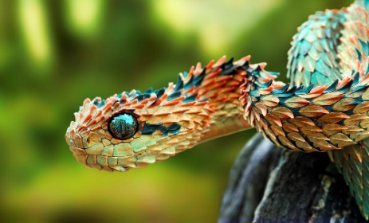](https://www.google.co.uk/url?sa=i&rct=j&q=&esrc=s&source=images&cd=&cad=rja&uact=8&ved=0ahUKEwiagbX6uazSAhVMDcAKHYE8BvIQjRwIBw&url=http://rebrn.com/re/african-bush-viper-274110/&bvm=bv.148073327,d.ZGg&psig=AFQjCNHGk6Zo8gWgrDm3xFjMsPaUBU4j9Q&ust=1488153487006169)

There are 5 of them - 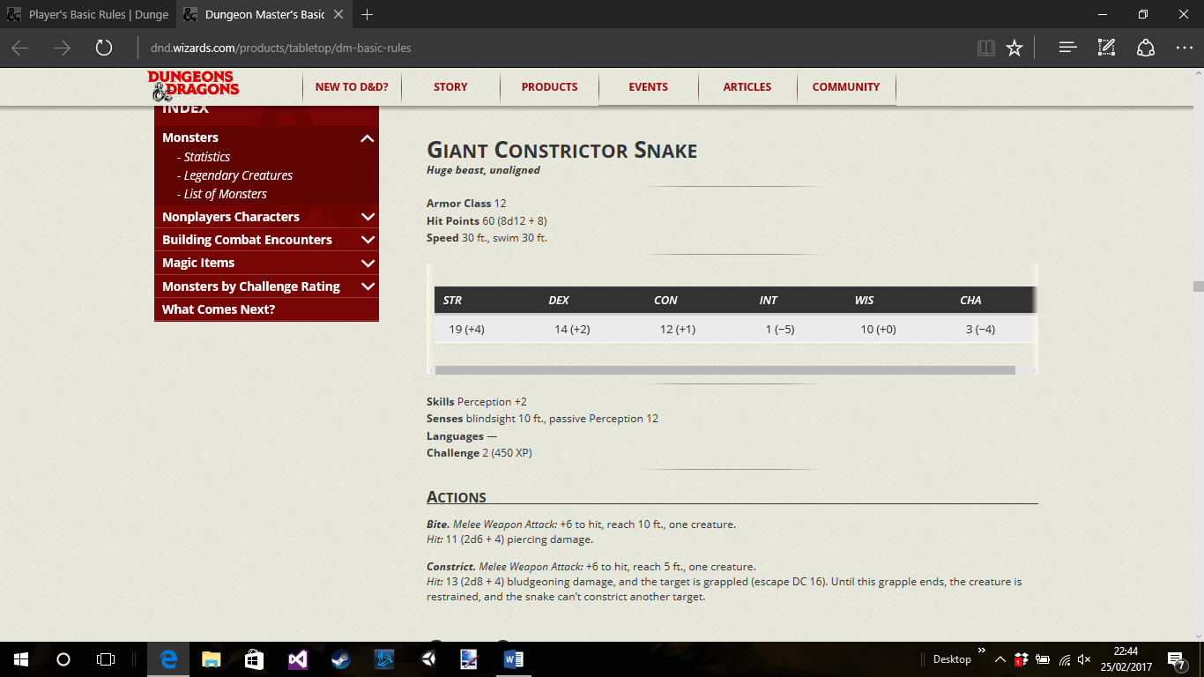

If four of the five snakes are killed, then the last tries to escape to the East, This snake slithers up the eastern wall and into a small tunnel around 30 feet up the wall. The snake moves too fast and cannot be stopped by the players.

After this fight if successful the players get 900XP divided between them.

Loot: There is no loot from the snakes as they have no venom, their skin is scaly and hard however it cannot be cut and added to the player’s armour.

Cavern – tunnels

From the starting location there are three possible tunnels the players can enter, now most of “The Dark Below is uncharted grounds and therefor it is completely random as to what the players can run into. However from the first room they can only go three ways:

* South
* East
* Climb up east – where the snake went.
  + *Where the snake went*
  + *When the players enter the tunnel where the snake went they will find the tunnel gets smaller and smaller until they cannot fit, there is slime on the walls where the snakes slither through, the moisture on the walls makes it seem like there is some form of water nearby however you will not be able to reach it.*

The height and width of the tunnels will relatively always be the same size around 20 feet wide and 30 feet upwards.

When entering a tunnel the players get to roll if there is any form of light inside it using the following table roll 2D12:

* Glowing mushrooms 2 - 3
* Glowing crystals 4 - 6
* Glow worms 7 - 9
* No lights 10 - 20
* Will – o – wisp 21 - 23
* Lava 24

When entering a tunnel the tunnel will also flow in random ways, it is also down to dice to decide whether or not the tunnel will lead to a dead end:

For a dead end the DM will roll a D20 – on a 1 the tunnel is a dead end on a 20 the tunnel contains a small shop ran by one of four races (1D4):

* Gnome
* Dwarf
* Drow
* Wizard

Shops will be stocked with random supplies determined on a single D8:

* Blacksmith
* Adventurers shops
* Alchemist
* Book stores
* Fishing shop
* Armourers store
* Mixed bag
* Tavern

The starting tunnels will not have dead ends or shops in but after leaving the first tunnels into open caverns the tunnels from after this point can contain anything.

First Caverns

The first three caverns the players can enter will have set locations however like the tunnels after this point they will random.

* The first cavern
  + This cavern is large, around 60 feet in diameter and around 40 feet up to the ceiling.
  + This cavern has a small pool of water in it, the water seems to be trickling down the rock and into the small pool, it would of taken a very long time for this pool to fill to this size.
    - There is nothing of note inside the pool, however the water is slightly murky and if a player were to drink it they would feel sick, if they do not do a constitution save of DC 8 they will throw up and lose a single hit point.
    - The pool water could be gathered in a flask and boiled to make clean water.
  + Other than the pool in this room which is around 10 feet by 10 feet against the Eastern wall there are only two more things of note in this cavern.
  + Against the Northern wall there is a small rock outcropping, big enough for the party to hunker down and get a rest, either short or long.
  + Against the Southern wall there is a small tunnel, the players would have to lay flat on their stomachs to crawl through this, it would take 1 action to lay flat and another to stand.
    - The tunnel is full of skulls and bones.
    - The tunnel enters another room, the room is about 15 foot by 15 foot, the ceiling here only reaches up about 15 feet.
      * Inside the room there is a small shrine to an unknown deity, on the shrine there is a dusty book, the players cannot read the language as it is an unknown language.
      * That’s all there is in this room.
* No tunnels lead out from this room, this room is mainly a room for the players to return too and rest at if they can, it is a designated safe area.

Second Cavern

If the players go South they reach a large cavern. This one is small that the first room but still large in its own way. The room is around 50 feet in diameter and the players cannot see the ceiling from where they are. This room has a three skeletons in it, the skeletons are on the ground, they look like they have been here for a few years at least. Along with the skeleton there is also an empty suit of plate armour, the armour sits in a pile near the skeleton.

*When the players enter the room, the DM will roll a D20, on the roll of a 15 or more (naturally) the skeletons will re-animate, the players will hear a few cracks and creaks as life returns to the Skeletons. However along with the Skeletons the suit of armour also animates itself, they are all hostile to the players however the noise these creatures make means that they will not surprise the players.*

The skeletons and Amrour have stats (check the monster manual).

After the skeletons and the armour have been defeated – *The skeletons crumble completely and their bones fall apart. The suit of armour turns into ash and is blown away into the wind of the cavern. As the armour dies you hear a faint whisper “Thank you” as it dies.*

The players get 350XP to split between them.

*After the end of the fight the players can explore the rest of the cavern, the rest of the cavern doesn’t reveal much, which is expected as this place has only just recently be discovered by your party. The rest of the cavern has a few small boxes and an old empty fire place where the skeletons once lay. The small boxes contain :*

* *A single torch*
* *A tinderbox*
* *3D6 x 10 cp.*

The players don’t find anything else in this room, however if a player can see a thieves cantt , there is one here, this is a small symbol and it must have been drawn nearly a decade or two ago. However the cantt reads something along the lines of – “not our land, land belongs to else, leave now, danger everywhere”

Other than this there is nothing else in the room.

There are two tunnels in this place, one leading west and another tunnel going East.

Tunnels.

* Roll for tunnel direction on a D4
  + 1 – East
  + 2 – North
  + 3 – West
  + 4 – South
* Roll table for tunnels on a D100
  + 0-10 – Monster encounter
  + 11-20 – Random Room
  + 21-20 – Cavern
  + 31-40 – Monster table
  + 41-50 – Cavern
  + 51-60 – Random Room
  + 61-70 – Monster table
  + 71-80 – Cavern
  + 81-90 – Underground village
  + 91-100 – Random Room
* Random Room
* Monster Ecounter
* Underground village
  + A small village of friendly folk
    - The village doesn’t contain any farming equipment but they do grow large mushroom which can be used for food.
    - The locals are usually dwarves or gnomes
    - The village always contains an inn for the players to rest and stay
    - Always contains a shop to buy food.
    - If they ask for directions to the Drow city
      * The players are told the general direction and for the next 3 tunnels the players will only enter tunnels that go in that direction, this way they can find the city easier.

Caverns.

Caverns vary in size, from small to huge roll a 1D4.

* Small size - 1
* Medium size - 2
* Large size - 3
* Huge size - 4

Small

This cavern is around 15 feet in diameter and has a ceiling which is around 20 feet above you, the roof is covered with stalactites.

Medium

This cavern is around 30 feet in diameter and has a ceiling which is around 35 feet above you, the roof of this cavern is smooth and held up by a single column.

Large

This cavern is around 55 feet in diameter and has a ceiing which is around 65 feet above you, the roof of this cavern is covered in stalactites and the roof is held up by multiple stone column that vary in thickness.

Huge

This cavern is around 80 feet in diameter and has a ceiling which goes beyond what the players can see, this room looks almost man made as it has been smoothed out so much by the wind however it is being held up by a massive column that is in the centre of the room.

Caverns and tunnels can contain any of the following – Roll a D6 on an odd it contains one of these on and even it does not.

1.Ghostly echoes, 2.Random noises, 3.Rockfalls, 4.Old mineshafts, 5.Pools of saliva, 6.An abandoned well, 7.A recently snuffed out fire, 8.Players can have random visions, 9.Singing rocks, 10.Slate floors, 11.Lava pools, 12.Large eggs (unhatched), 13.large hatched eggs, 14.Dragon treasure horde, 15.Map scraps, 16.Shrines, 17.a complete garden – with growing grass – statues – a bird bath and other assortments, 18.Easel with a freshly painted watercolour painting, 19.a portal which something falls out of, 20.a children’s playground, 21.Ghosts, 22.Crack with water running out of it – can be salt - fresh or poison water, 23.a large underground cathedral, 24.Earthquakes, 25.abandoned villages, 26.a woman playing the harp, 27.*OUR HOUSE, 28.*Cave drawings/markings, 29.Warnings in a language only one person can understand, **30.Coin carrier hearing things when others cannot**, 31.Upside down room – the lake is on the ceiling not on the ground, gravity is reversed after a certain height, 32.Spider webs, 33.a large silver prison door, 34.a hanging noose attached to a stone tree, 35.Snow white type tomb, 36.a cavern which is half filed with water inhabited with mer-people, 37.Mirror which sees into another location in the world – this mirror shows the map of the caves, 38.a gun (looks like a miniature cannon, never been seen before, 2 shots), 39.a story book of sorts, 40.a room covered in snow – petrified trees. Werewolf, Vampire, a troll, a trap, medusa, stone men, celestial book, Sword in the stone, death knight, wooden door with a horde of undead behind, demon skeleton, a lake of ice.

The players should level up a few times within The Dark Below. By the time they reach the city they should have completed some of the above, they should also be around a level 8 or 9.

After doing a few of these things (around 15 of them) the players will enter a tunnel which has torches on the walls, after a few miles you come across torches more and more frequently until you enter a humongous cavern, inside this cavern is a large city carved from marble and moon rocks and glow even in the darkness, the city is well lit and as you approach 8 guards come forward to meet you, they are all Drow however one of them is a Dwarf.

“Hail travellers, so you’ve come out of The Dark Below, an impressive feat, did you stick to the marked tunnels? “

* The players did not

“You venture into the unknown? Well, well that’s not been done in a while. Tell me did you map out these tunnels at all? We would pay generously for them.”

* They would pay the players per tunnel and cavern they have mapped out, they would pay 1D4 per tunnel and 1D6 per cavern, they pay in gold and would times the total by 100.
  + 14 tunnels and 12 caverns
    - 14D4 + 12D6 x 100 = 35 + 35 x 100 = 700gp

Depending on the amount of exploring players did, they can get a lot of gold to split and spend in the city, however they will be unable to return into the tunnels that they have just left.

Drow City of Undersark

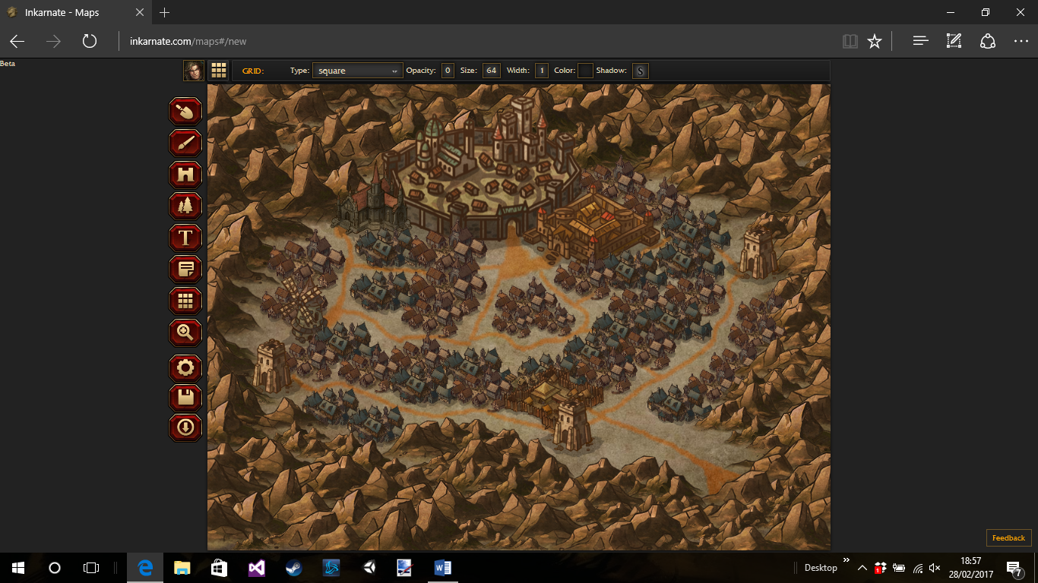

Ravenscroft Windmill

Entrance to the city

Drow battalion

Palace of the Queen

Order of the dark rangers

Watchtowers

Square of Steel

Street of spiders

Temple of Guntyr

Udrnsark

This is a city full of Drow, Dwarves and gnomes – most of the inhabitants are friendly even to outsiders, which is rare for Drow, the city is prosperous as there is a lot of trade coming in from Temerigaard due to the recent trade deal between the queen and the emperor. Players will be able to buy weapons and armour from the square of steel and visit the various taverns in the city. They can also buy black market goods on the street of spiders.

Queens quest

When arriving at the city the players can seek out the royal guard and be asked to taken before the queen, depending on how they as depends on how they get to meet the queen.

The queen is a tall Drow female, she is in all terms beautiful and has long white hair that goes down to her waist, it has been plaited. She wears a silver/white gown with a Moon Stone crown. She has a soft voice and carries a thin but large sword at her waist.

She tells the players about how the emperor came down here to treat with her and she accepted for the good of her realm, however there were some downsides, she had to send a large portion of drow with the emperor to fight in his war, which leaves the city open to attack.

The emperor himself came down here and took one of the ancient routes to the sealed entrance under Neverwinter. The queen warned the emperor about going this way however he did not listen and went with the vanguard of the army and a group of drow into the sealed passage. The queen points out the old sealed tunnel, it has been sealed by large steel bars, the steel bars are around 15 feet in diameter, there are small to large chains covering most of the entrance, however there is a gap through which the emperor went. The tunnels are home to all manners of horrors, and anything could be down there.

*The queens quest is to go and find the emperor in the tunnel and kill him, if the players find the emperor the queen tells them to find her Drow and have them return with the players, there are around 15 of them, if the emperor was to die in the tunnels the queen could spin it in a way that favours both her empire and the empires above, with the emperor dead his crusade against the world would be over.*

*This could be seen as a villainous act however because it benefits the world overall then the players are able to accept, however they may not have to kill the emperor, they also may never find the emperor in the tunnels.*

This will be the last time in a while for the players to buy supplies, they should replace their backpacks for ones that aren’t damaged, they can also buy mules that can carry up to 20 items. The players will have their management hit the extreme in the ancient tunnels. Also from here on the players may suffer TPK (Total player kills).

The Dark Below Part 2

The players now have a general direction, which they can go in. They know the emperor went through here and the first few tunnels are the same but after these tunnels they return to the tunnels like earlier in the campaign.

* Players can follow some of the tracks from the army as the path is originally dirt so they can see imprints.
* The army seems to be large and they have moved through here only a few days ago at least.
* The tracks stop after a while as the tunnels turn into rock more than anything else.

The players go through the tunnel and it winds left and then right and after around an hour you enter a large tunnel.

The rock cavern

You enter a large rock cavern in which the army must have passed through. However, the tunnels branch into three different direction. From here the players will be using the mapping system again.

Ancient tunnel random encounters

Using the rest of the encounters and when they are all gone add these.

Giants forge, a large pit, a chained up blind silver dragon, Large cavern with huge dwarven pillars, cultist praying to a devil, a cavern full of men that have been crucified, a large amount of dead Temerigaardian troops, a labyrinth, a crushed up train car, a large bell, Valter Sin doppelganger, a few fur tents, a smugglers store room that’s covered in dust, a large war ship (man o war), A stone throne with a series of skulls around the base, A large wall with draconic writing all over it, a cursed weapon, a large dining hall (ogres), a crazy man, a nothic lair, a large cavern with an adult red dragon inside, Ghost of Falchion Dreyar, A monk, a group of confused bandits.

The players will find every room from this point and then be able to continue.